
A science to his artwork
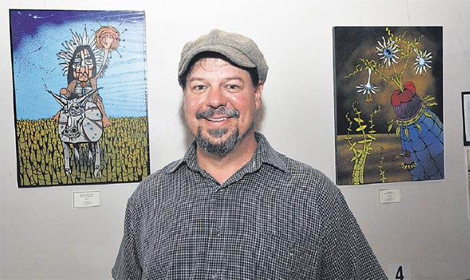
Thursday, January 22, 2015 by Kayla Dalrymple
AN exhibition created using a fascinating medium, by seemingly contradictory artist American Sam Koss, has opened at Verve Cafe.
Koss is a science teacher who makes art, a Catholic atheist, he smokes meat next to his organic garden and he paints nature with a toxic medium, spray paint.
Even his artistic process seems nonsensical, until you see the fine-lined illustrations his spray paint musings create.
There is a method to the madness for the Portland, Oregon man. His work is thought-provoking and, if you consider how he constructs his images, amazing.
Hand-cut stencils and spray paint are hardly a new combination. Its origins are in street graffiti, where stencils allowed artists to mass-produce images quickly in order to avoid authorities.
Koss uses layers and layers of stencils for one body of work, often not glimpsing the finished product until all the stencils are peeled off. The process can take days.
This is his first showing in more than a year.
He moved here three months ago with his wife Ericka and youngest daughter Amelia, nine, having never set foot in the country before. Older daughter Zoe, 21, still lives in America.
“My garage was crashed into by a group of drunk boys in the States. We were inside and we just heard an earth-shattering explosion and I thought ‘woah, this is the big one’.
“The car looked like it had dropped out of the sky and just landed in my garage. They took the car right through and ruined my studio.”
Shortly afterwards Ericka, an engineer, got a job offer in Gisborne.
“Between that and moving I have not really done a lot of art lately. But since I have been here I have been experimenting with other mediums, like pastels and water colour. My comfort zone is ink and illustration though.”
Legally he was not able to bring his spray paint collection over to New Zealand, leaving a couple of hundred cans lying dormant in America — quite a collection to rebuild.
“About three months ago a shipping container arrived with many of my stencil works, so I thought I would have a showing. If people like it I will use the proceeds to buy more spray paint and keep going.”
Koss’s works depict a range of different topics. His focus varies so much that — aside from his distinct spray and stencil style — one could be forgiven for thinking a different artist had created some pieces.
One such piece is a political expression in dark blue and navy tones. The pastel work depicts Barack Obama in the midst of the Ferguson protests, following the shooting of Michael Brown last year.
“That is the first political piece I have done in a really long time. I just thought he is so protected, what if he was just there in amongst it all.”
Another piece depicts a prehistoric creature pulling a gramophone into the ocean, with hints of Japanese woodblock wave and cloud prints.
“I was reading this science fiction novel at the time. It had to do with the distortion of time and taking different things, and then layering them into the same environment.
“It was a very visual experience for me and I do a lot of doodling, so I sort of just came up with the idea.”
Different works depict Trilobites, an extinct marine arthropod — not surprising considering Koss’s interesting work history and affinity with nature.
“Before I worked as a teacher I used to catalogue wildlife for the Mt. Hood National Forest service in my area.
“I mostly worked in ancient old growth forests. I would catalogue owls, rare rodents, bats and carnivores, but my favourite was insects.”
Koss got his start in the art world illustrating concert posters in college.
He is a teacher at heart, though, and after having his teaching qualifications approved by the Ministry of Education, he is excited to see what Gisborne has in store for him.
“I just really love art. It is about being able to move forward and know that any interpretation people might have of my work, it still had value.
“If my garage were to set on fire and all this work was lost, it would not have been wasted time. The entire artistic process is valuable. I am learning all the time and it feels good.

